Week 1
1 | Write a python program to compute Central Tendency Measures: Mean, Median, Mode Measure of Dispersion: Variance, Standard Deviation using following packages. a)Staticstics b) Math c) Numpy d) Scipy.
import numpy as np
import statistics
import math
from scipy import stats
# Sample dataset
data = [12, 15, 14, 10, 18, 15, 14, 16, 15, 17]
# Using statistics module
mean_stats = statistics.mean(data)
median_stats = statistics.median(data)
mode_stats = statistics.mode(data)
variance_stats = statistics.variance(data)
std_dev_stats = statistics.stdev(data)
# Using numpy module
mean_np = np.mean(data)
median_np = np.median(data)
mode_np = stats.mode(data, keepdims=True).mode[0] # Fix for newer SciPyversions
variance_np = np.var(data, ddof=1) # ddof=1 for sample variance
std_dev_np = np.std(data, ddof=1) # ddof=1 for sample std deviation
# Using math module (only standard deviation)
std_dev_math = math.sqrt(variance_stats)
# Using scipy module
mode_scipy = stats.mode(data, keepdims=True).mode[0] # Fix applied
variance_scipy = np.var(data, ddof=1)
std_dev_scipy = np.std(data, ddof=1)
# Printing results
print("Central Tendency Measures:")
print(f"Mean (statistics): {mean_stats}")
print(f"Mean (numpy): {mean_np}")
print(f"Median (statistics): {median_stats}")
print(f"Median (numpy): {median_np}")
print(f"Mode (statistics): {mode_stats}")
print(f"Mode (scipy): {mode_scipy}")
print("\nMeasures of Dispersion:")
print(f"Variance (statistics): {variance_stats}")
print(f"Variance (numpy): {variance_np}")
print(f"Variance (scipy): {variance_scipy}")
print(f"Standard Deviation (statistics): {std_dev_stats}")
print(f"Standard Deviation (numpy): {std_dev_np}")
print(f"Standard Deviation (scipy): {std_dev_scipy}")
print(f"Standard Deviation (math): {std_dev_math}")

OUTPUT:
Central Tendency Measures:
Mean (statistics): 14.6
Mean (numpy): 14.6
Median (statistics): 15.0
Median (numpy): 15.0
Mode (statistics): 15
Mode (scipy): 15

Measures of Dispersion:
Variance (statistics): 5.377777777777778
Variance (numpy): 5.377777777777778
Variance (scipy): 5.377777777777778
Standard Deviation (statistics): 2.3190036174568114
Standard Deviation (numpy): 2.3190036174568114
Standard Deviation (scipy): 2.3190036174568114
Standard Deviation (math): 2.3190036174568114

Week 2
2 | Implementation of Python Libraries for ML application such as Pandas and Matplotlib for Iris Dataset.
import pandas as pd
import matplotlib.pyplot as plt
from sklearn import datasets # Load Iris dataset from scikit-learn
# Load the Iris dataset from scikit-learn
dir(datasets)
iris = datasets.load_iris()
# Creating a DataFrame
iris_df = pd.DataFrame(iris.data, columns=iris.feature_names)
iris_df['species'] = iris.target # Add target labels
# Map target numbers to actual species names
iris_df['species'] = iris_df['species'].map({0: 'setosa', 1: 'versicolor', 2:
'virginica'})
# Display first few rows
print("First 5 rows of Iris Dataset:")
print(iris_df.head())
# Display basic statistics
print("\nBasic Statistics:")
print(iris_df.describe())
# Display column names
print("\nColumn Names:")
print(iris_df.columns)
# Visualizing the data using Matplotlib
plt.figure(figsize=(8, 6))
colors = {'setosa': 'red', 'versicolor': 'green', 'virginica': 'blue'}
for species in iris_df['species'].unique():
subset = iris_df[iris_df['species'] == species]
plt.scatter(subset['sepal length (cm)'], subset['sepal width (cm)'],
label=species, color=colors[species])
plt.title("Sepal Length vs Sepal Width")
plt.xlabel("Sepal Length (cm)")
plt.ylabel("Sepal Width (cm)")
plt.legend(title='Species')
plt.grid(True)
plt.show()
# Boxplot for petal length grouped by species
plt.figure(figsize=(8, 6))
for index, species in enumerate(iris_df['species'].unique()):
subset = iris_df[iris_df['species'] == species]
plt.boxplot(subset['petal length (cm)'], positions=[index], widths=0.5)
plt.xticks([0, 1, 2], iris_df['species'].unique())
plt.title("Petal Length Distribution by Species")
plt.xlabel("Species")
plt.ylabel("Petal Length (cm)")
plt.show()
# Save the DataFrame to a CSV file
iris_df.to_csv('iris_dataset.csv', index=False)
print("\nIris dataset has been saved to 'iris_dataset.csv'.”)

OUTPUT:

First 5 rows of Iris Dataset:
sepal length (cm) sepal width (cm) petal length (cm) petal width (cm) \
0 5.1 3.5 1.4 0.2
1 4.9 3.0 1.4 0.2
2 4.7 3.2 1.3 0.2
3 4.6 3.1 1.5 0.2
4 5.0 3.6 1.4 0.2

species
0 setosa
1 setosa
2 setosa
3 setosa
4 setosa

Basic Statistics:
sepal length (cm) sepal width (cm) petal length (cm) \
count 150.000000 150.000000 150.000000
mean 5.843333 3.057333 3.758000
std 0.828066 0.435866 1.765298
min 4.300000 2.000000 1.000000
25% 5.100000 2.800000 1.600000
50% 5.800000 3.000000 4.350000
75% 6.400000 3.300000 5.100000
max 7.900000 4.400000 6.900000

petal width (cm)
count 150.000000
mean 1.199333
std 0.762238

min 0.100000
25% 0.300000
50% 1.300000
75% 1.800000
max 2.500000

Column Names:
Index(['sepal length (cm)', 'sepal width (cm)', 'petal length (cm)',
'petal width (cm)', 'species'],
dtype='object')

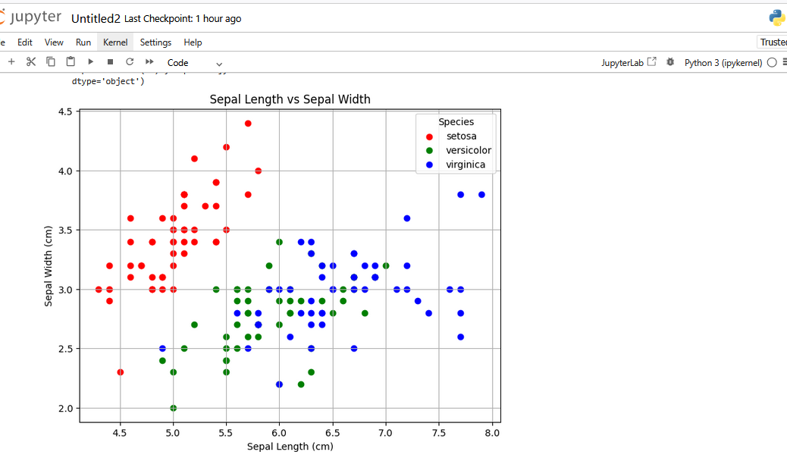

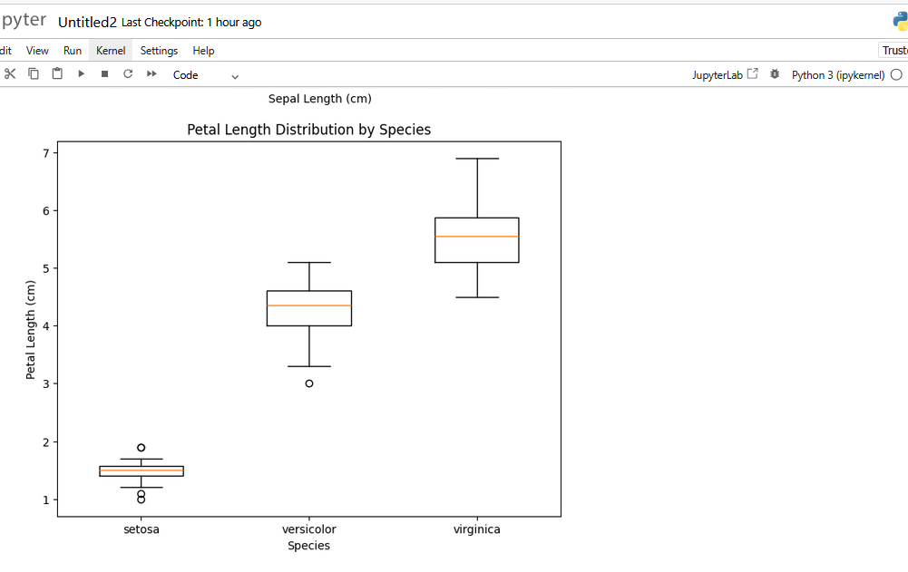

Iris dataset has been saved to 'iris_dataset.csv'.

Week 3
3 | Write a Python program to implement Simple Linear Regression.
import numpy as np
import matplotlib.pyplot as plt
from sklearn.linear_model import LinearRegression
from sklearn.metrics import mean_squared_error, r2_score
# Data
X = np.array([5, 15, 25, 35, 45, 55]).reshape((-1, 1))
Y = np.array([5, 20, 14, 32, 22, 38])
print("X:", X)
print("Y:", Y)
# Create and train the model
model = LinearRegression()
model.fit(X, Y)
# Coefficient of determination
r_sq = model.score(X, Y)
print("Coefficient of determination (R^2):", r_sq)
# Model parameters
print("Intercept:", model.intercept_)
print("Slope:", model.coef_)
# Predicted response
Y_pred = model.predict(X)
print("Predicted response:", Y_pred)
# Visualization
plt.scatter(X, Y, color='blue', label='Actual')
plt.plot(X, Y_pred, color='red', label='Predicted')
plt.xlabel('X (Independent variable)')
plt.ylabel('Y (Dependent variable)')
plt.title('Simple Linear Regression')
plt.legend()
plt.show()

OUTPUT:
X: [[ 5]
[15]
[25]
[35]
[45]
[55]]
Y: [ 5 20 14 32 22 38]
Coefficient of determination (R^2): 0.7158756137479542
Intercept: 5.633333333333329
Slope: [0.54]
Predicted response: [ 8.33333333 13.73333333 19.13333333 24.53333333 29.93333333 35.33333333]

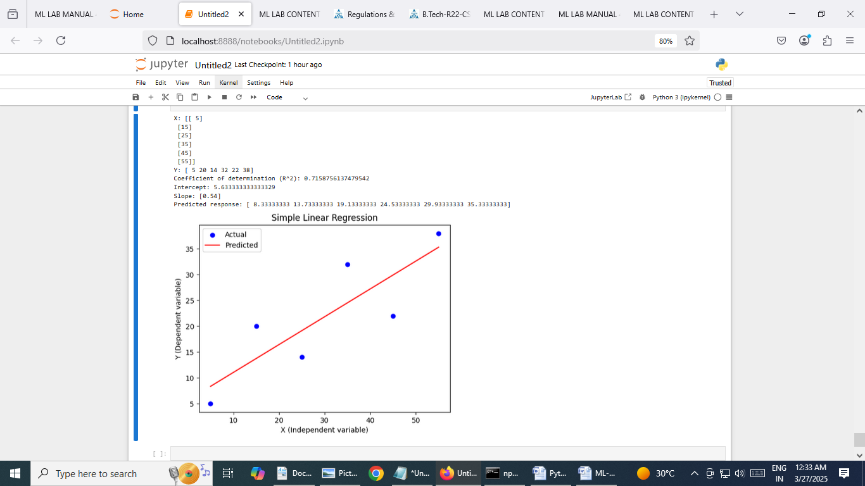

Week 4
4 | Implementation of Multiple Linear Regression for House Price Prediction using sklearn.
# Required Libraries
import numpy as np
import pandas as pd
from sklearn.datasets import fetch_california_housing
from sklearn.model_selection import train_test_split
from sklearn.linear_model import LinearRegression
from sklearn.metrics import mean_squared_error, r2_score
import matplotlib.pyplot as plt
# Load Dataset
house_data = fetch_california_housing()
x = pd.DataFrame(house_data.data, columns=house_data.feature_names)
y = pd.Series(house_data.target)
# Display Dataset Description
print(house_data.DESCR)
# Splitting the Dataset
X_train, X_test, y_train, y_test = train_test_split(x, y, test_size=0.2,
random_state=42)
1
# Initialize and Train the Model
model = LinearRegression().fit(X_train, y_train)
# Make Predictions
y_pred = model.predict(X_test)
# Model Evaluation
mse = mean_squared_error(y_test, y_pred)
r2 = r2_score(y_test, y_pred)
# Output Model Coefficients and Metrics
print("Model Coefficients:", model.coef_)
print("Model Intercept:", model.intercept_)
print("Mean Squared Error:", mse)
print("R-squared:", r2)
# Display Actual vs Predicted Values
comparison = pd.DataFrame({'Actual Price': y_test, 'Predicted Price': y_pred})
print(comparison.head())
# Visualization
plt.figure(figsize=(10, 6))
plt.scatter(y_test, y_pred, color='blue', edgecolor='k', alpha=0.7)
plt.plot([min(y_test), max(y_test)], [min(y_test), max(y_test)],
color='red', linestyle='--', linewidth=2)
plt.title('Actual vs Predicted House Prices')
plt.xlabel('Actual Price')
plt.ylabel('Predicted Price')
plt.grid(True)
plt.show()

OUTPUT:

.. _california_housing_dataset:

California Housing dataset
--------------------------

**Data Set Characteristics:**

:Number of Instances: 20640

:Number of Attributes: 8 numeric, predictive attributes and the target

:Attribute Information:
- MedInc median income in block group
- HouseAge median house age in block group
- AveRooms average number of rooms per household
- AveBedrms average number of bedrooms per household
- Population block group population
- AveOccup average number of household members
- Latitude block group latitude
- Longitude block group longitude

:Missing Attribute Values: None

This dataset was obtained from the StatLib repository.
https://www.dcc.fc.up.pt/~ltorgo/Regression/cal_housing.html

The target variable is the median house value for California districts,
expressed in hundreds of thousands of dollars ($100,000).

This dataset was derived from the 1990 U.S. census, using one row per census
block group. A block group is the smallest geographical unit for which the U.S.
Census Bureau publishes sample data (a block group typically has a population
of 600 to 3,000 people).

A household is a group of people residing within a home. Since the average
number of rooms and bedrooms in this dataset are provided per household, these
columns may take surprisingly large values for block groups with few households
and many empty houses, such as vacation resorts.

It can be downloaded/loaded using the
:func:`sklearn.datasets.fetch_california_housing` function.

.. rubric:: References

- Pace, R. Kelley and Ronald Barry, Sparse Spatial Autoregressions,
Statistics and Probability Letters, 33 (1997) 291-297

Model Coefficients: [ 4.48674910e-01 9.72425752e-03 -1.23323343e-01 7.83144907e-01
-2.02962058e-06 -3.52631849e-03 -4.19792487e-01 -4.33708065e-01]
Model Intercept: -37.023277706064064
Mean Squared Error: 0.555891598695244
R-squared: 0.5757877060324511
Actual Price Predicted Price
20046 0.47700 0.719123
3024 0.45800 1.764017
15663 5.00001 2.709659
20484 2.18600 2.838926
9814 2.78000 2.604657

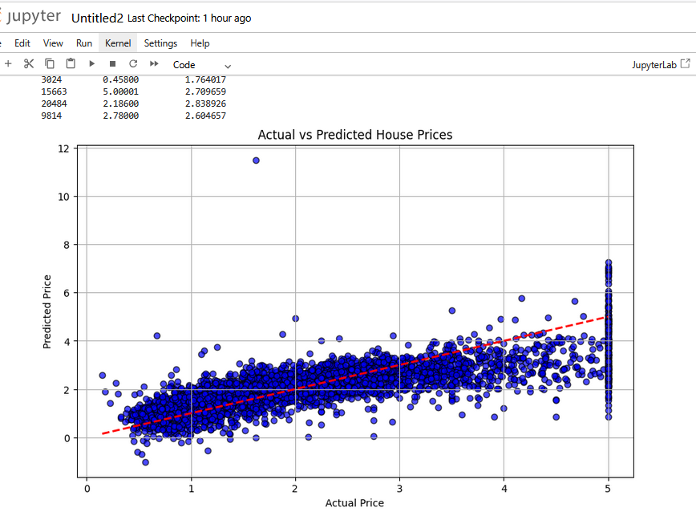

Week 5
5 | Implementation of Decision tree using sklearn and its parameter tuning.
import numpy as np
import pandas as pd
from sklearn.datasets import load_iris
from sklearn.tree import DecisionTreeClassifier
from sklearn.model_selection import train_test_split, GridSearchCV
from sklearn import metrics
import matplotlib.pyplot as plt
from sklearn import tree
# Load the Iris dataset
iris = load_iris()
X = iris.data # Features
y = iris.target # Target
# Description of Iris Dataset
print(iris.DESCR)
# Splitting the dataset into training and testing sets (80% train, 20% test)
X_train, X_test, y_train, y_test = train_test_split(X, y, test_size=0.2, random_state=42)
# Creating the Decision Tree model with initial parameters
model = DecisionTreeClassifier(criterion='entropy', random_state=42)
# Training the model
model.fit(X_train, y_train)
# Predicting the target for the test data
y_pred = model.predict(X_test)
# Evaluating the model's accuracy
accuracy = metrics.accuracy_score(y_test, y_pred)
print("Accuracy before tuning:", accuracy)
# Parameter tuning using GridSearchCV
param_grid = {
'criterion': ['gini', 'entropy'],
'max_depth': [3, 5, 7, None],
'min_samples_split': [2, 5, 10]
}
grid_search = GridSearchCV(DecisionTreeClassifier(random_state=42), param_grid, cv=5)
grid_search.fit(X_train, y_train)
# Best parameters and accuracy after tuning
best_model = grid_search.best_estimator_
print("Best Parameters:", grid_search.best_params_)
print("Best Model Accuracy after tuning:", grid_search.best_score_)
# Final prediction using the best model
y_pred_best = best_model.predict(X_test)
final_accuracy = metrics.accuracy_score(y_test, y_pred_best)
print("Final Accuracy with tuned model:", final_accuracy)
# Visualizing the best Decision Tree
plt.figure(figsize=(12, 8))
tree.plot_tree(best_model, filled=True, feature_names=iris.feature_names, class_names=iris.target_names, rounded=True)
plt.title("Tuned Decision Tree")
plt.show()

OUTPUT:

.. _iris_dataset:

Iris plants dataset
--------------------

**Data Set Characteristics:**

:Number of Instances: 150 (50 in each of three classes)
:Number of Attributes: 4 numeric, predictive attributes and the class
:Attribute Information:
- sepal length in cm
- sepal width in cm
- petal length in cm
- petal width in cm
- class:
- Iris-Setosa
- Iris-Versicolour
- Iris-Virginica

:Summary Statistics:

============== ==== ==== ======= ===== ====================
Min Max Mean SD Class Correlation
============== ==== ==== ======= ===== ====================
sepal length: 4.3 7.9 5.84 0.83 0.7826
sepal width: 2.0 4.4 3.05 0.43 -0.4194
petal length: 1.0 6.9 3.76 1.76 0.9490 (high!)
petal width: 0.1 2.5 1.20 0.76 0.9565 (high!)
============== ==== ==== ======= ===== ====================

:Missing Attribute Values: None
:Class Distribution: 33.3% for each of 3 classes.
:Creator: R.A. Fisher
:Donor: Michael Marshall (MARSHALL%PLU@io.arc.nasa.gov)
:Date: July, 1988

The famous Iris database, first used by Sir R.A. Fisher. The dataset is taken
from Fisher's paper. Note that it's the same as in R, but not as in the UCI
Machine Learning Repository, which has two wrong data points.

This is perhaps the best known database to be found in the
pattern recognition literature. Fisher's paper is a classic in the field and
is referenced frequently to this day. (See Duda & Hart, for example.) The
data set contains 3 classes of 50 instances each, where each class refers to a
type of iris plant. One class is linearly separable from the other 2; the
latter are NOT linearly separable from each other.

.. dropdown:: References

- Fisher, R.A. "The use of multiple measurements in taxonomic problems"
Annual Eugenics, 7, Part II, 179-188 (1936); also in "Contributions to
Mathematical Statistics" (John Wiley, NY, 1950).
- Duda, R.O., & Hart, P.E. (1973) Pattern Classification and Scene Analysis.
(Q327.D83) John Wiley & Sons. ISBN 0-471-22361-1. See page 218.
- Dasarathy, B.V. (1980) "Nosing Around the Neighborhood: A New System
Structure and Classification Rule for Recognition in Partially Exposed
Environments". IEEE Transactions on Pattern Analysis and Machine
Intelligence, Vol. PAMI-2, No. 1, 67-71.
- Gates, G.W. (1972) "The Reduced Nearest Neighbor Rule". IEEE Transactions
on Information Theory, May 1972, 431-433.
- See also: 1988 MLC Proceedings, 54-64. Cheeseman et al"s AUTOCLASS II
conceptual clustering system finds 3 classes in the data.
- Many, many more ...
Accuracy before tuning: 1.0
Best Parameters: {'criterion': 'gini', 'max_depth': 7, 'min_samples_split': 2}
Best Model Accuracy after tuning: 0.9416666666666668
Final Accuracy with tuned model: 1.0

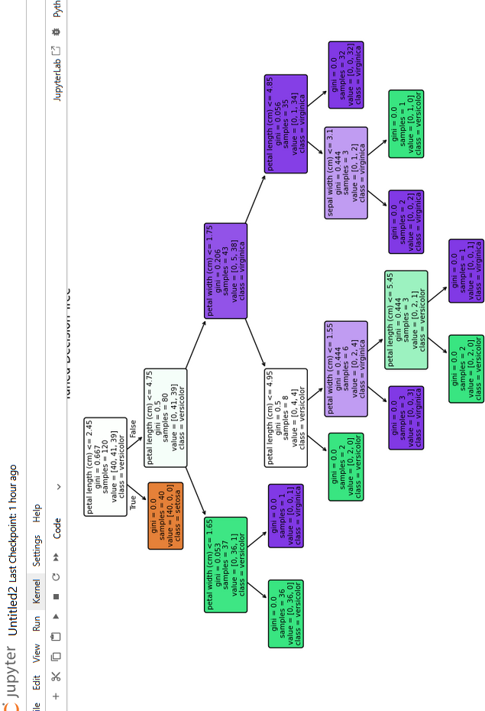

Week 6
6 | Implementation of KNN using sklearn.
# Required Libraries
import numpy as np
import matplotlib.pyplot as plt
from sklearn.neighbors import KNeighborsClassifier
from sklearn.model_selection import train_test_split
from sklearn.datasets import load_iris
from sklearn.metrics import accuracy_score, confusion_matrix

# Load Iris dataset
iris = load_iris()
X = iris.data[:, :2] # Take only the first two features for simplicity
y = iris.target
print(iris.DESCR) # Display dataset description

# Split the dataset into training and test sets
X_train, X_test, y_train, y_test = train_test_split(X, y, test_size=0.3, random_state=42)

# Initialize KNN model with k=3
knn = KNeighborsClassifier(n_neighbors=3)

# Train the model
knn.fit(X_train, y_train)

# Predict on test set
y_pred = knn.predict(X_test)

# Evaluation Criteria
accuracy = accuracy_score(y_test, y_pred)
conf_matrix = confusion_matrix(y_test, y_pred)
print(f"Accuracy: {accuracy * 100:.2f}%")
print("Confusion Matrix:")
print(conf_matrix)

# Visualization
plt.figure(figsize=(8, 6))
plt.scatter(X_train[:, 0], X_train[:, 1], c=y_train, cmap='coolwarm', marker='*', s=100, label='Training Data')
plt.scatter(X_test[:, 0], X_test[:, 1], c='green', marker='x', s=200, label='Test Data')

# Draw lines to nearest neighbors for each test point
for test_point in X_test:
distances, indices = knn.kneighbors([test_point])
for index in indices[0]:
neighbor = X_train[index]
plt.plot([test_point[0], neighbor[0]], [test_point[1], neighbor[1]], 'k--', lw=1)

plt.xlabel('Sepal length')
plt.ylabel('Sepal width')
plt.title('K-Nearest Neighbors Visualization (Iris Dataset)')
plt.legend()
plt.show()

OUTPUT:

.. _iris_dataset:

Iris plants dataset
--------------------

**Data Set Characteristics:**

:Number of Instances: 150 (50 in each of three classes)
:Number of Attributes: 4 numeric, predictive attributes and the class

:Attribute Information:
- sepal length in cm
- sepal width in cm
- petal length in cm
- petal width in cm
- class:
- Iris-Setosa
- Iris-Versicolour
- Iris-Virginica

:Summary Statistics:

============== ==== ==== ======= ===== ====================
Min Max Mean SD Class Correlation
============== ==== ==== ======= ===== ====================
sepal length: 4.3 7.9 5.84 0.83 0.7826
sepal width: 2.0 4.4 3.05 0.43 -0.4194
petal length: 1.0 6.9 3.76 1.76 0.9490 (high!)
petal width: 0.1 2.5 1.20 0.76 0.9565 (high!)
============== ==== ==== ======= ===== ====================

:Missing Attribute Values: None
:Class Distribution: 33.3% for each of 3 classes.
:Creator: R.A. Fisher
:Donor: Michael Marshall (MARSHALL%PLU@io.arc.nasa.gov)
:Date: July, 1988

The famous Iris database, first used by Sir R.A. Fisher. The dataset is taken
from Fisher's paper. Note that it's the same as in R, but not as in the UCI
Machine Learning Repository, which has two wrong data points.

This is perhaps the best known database to be found in the
pattern recognition literature. Fisher's paper is a classic in the field and
is referenced frequently to this day. (See Duda & Hart, for example.) The
data set contains 3 classes of 50 instances each, where each class refers to a
type of iris plant. One class is linearly separable from the other 2; the
latter are NOT linearly separable from each other.

.. dropdown:: References

- Fisher, R.A. "The use of multiple measurements in taxonomic problems"
Annual Eugenics, 7, Part II, 179-188 (1936); also in "Contributions to
Mathematical Statistics" (John Wiley, NY, 1950).
- Duda, R.O., & Hart, P.E. (1973) Pattern Classification and Scene Analysis.
(Q327.D83) John Wiley & Sons. ISBN 0-471-22361-1. See page 218.
- Dasarathy, B.V. (1980) "Nosing Around the Neighborhood: A New System
Structure and Classification Rule for Recognition in Partially Exposed
Environments". IEEE Transactions on Pattern Analysis and Machine
Intelligence, Vol. PAMI-2, No. 1, 67-71.
- Gates, G.W. (1972) "The Reduced Nearest Neighbor Rule". IEEE Transactions
on Information Theory, May 1972, 431-433.
- See also: 1988 MLC Proceedings, 54-64. Cheeseman et al"s AUTOCLASS II
conceptual clustering system finds 3 classes in the data.
- Many, many more ...

Accuracy: 75.56%
Confusion Matrix:
[[19 0 0]
[ 0 7 6]
[ 0 5 8]]

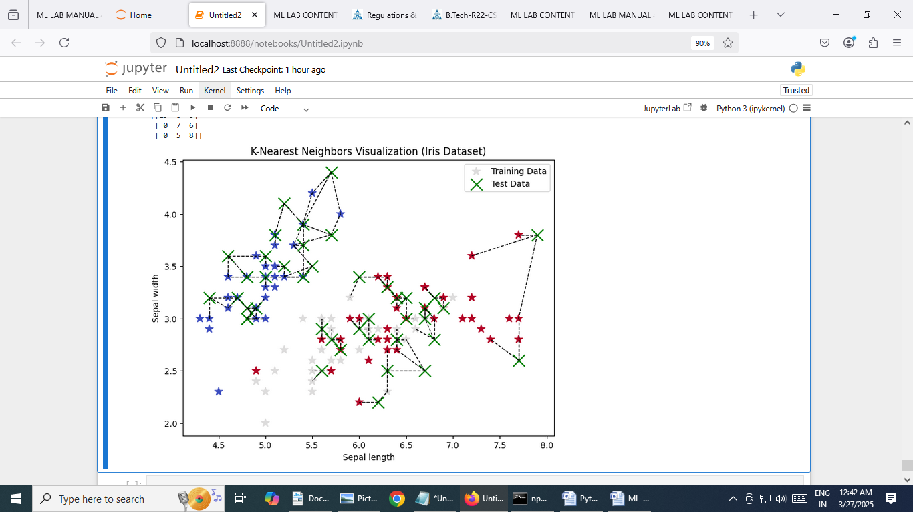

Week 7
7 | Implementation of Logistic Regression using sklearn.
# Required Libraries
import numpy as np
from sklearn.model_selection import train_test_split
from sklearn.linear_model import LogisticRegression
from sklearn.datasets import load_iris
from sklearn.metrics import accuracy_score, classification_report, confusion_matrix
# Loading the dataset (using Iris dataset as an example)
data = load_iris()
X = data.data
y = data.target
# Selecting only two classes for binary classification
X = X[y != 2, :2] # Using only the first two features for easy visualization
y = y[y != 2]
# Splitting the dataset into training and testing sets
X_train, X_test, y_train, y_test = train_test_split(X, y, test_size=0.3, random_state=42)
# Creating the Logistic Regression model
model = LogisticRegression()
# Training the model
model.fit(X_train, y_train)
# Making predictions
y_pred = model.predict(X_test)
# Evaluating the model
accuracy = accuracy_score(y_test, y_pred)
conf_matrix = confusion_matrix(y_test, y_pred)
class_report = classification_report(y_test, y_pred)
# Printing evaluation metrics
print("Accuracy:", accuracy)
print("Confusion Matrix:\n", conf_matrix)
print("Classification Report:\n", class_report)

OUTPUT
Accuracy: 1.0
Confusion Matrix:
[[17 0]
[ 0 13]]
Classification Report:
precision recall f1-score support

0 1.00 1.00 1.00 17
1 1.00 1.00 1.00 13

accuracy 1.00 30
macro avg 1.00 1.00 1.00 30
weighted avg 1.00 1.00 1.00 30

Week 8
8 | Implementation of K-Means Clustering.
# Required Libraries
import numpy as np
import matplotlib.pyplot as plt
from sklearn.cluster import KMeans
from sklearn.datasets import load_iris
from sklearn.metrics import adjusted_rand_score, silhouette_score
# Load Iris Dataset
iris = load_iris()
X = iris.data[:, :2] # Use only the first two features for 2D visualization
y = iris.target
# True labels for comparison (not used in clustering)
# Plotting the Original Data
plt.figure(figsize=(12, 5))
# Original Data
plt.subplot(1, 2, 1)
plt.scatter(X[:, 0], X[:, 1], c=y, cmap='viridis', marker='o', edgecolor='k', s=100)
plt.title('Original Iris Dataset')
plt.xlabel('Feature 1')
plt.ylabel('Feature 2')
plt.grid()
# K-Means Clustering
kmeans = KMeans(n_clusters=3, random_state=42)
kmeans.fit(X)
predictions = kmeans.predict(X)
# Evaluation Metrics
inertia = kmeans.inertia_
ari = adjusted_rand_score(y, predictions)
silhouette_avg = silhouette_score(X, predictions)
print(f"Inertia: {inertia:.2f}")
print(f"Adjusted Rand Index (ARI): {ari:.2f}")

print(f"Silhouette Score: {silhouette_avg:.2f}")
# Plotting the K-Means Result
plt.subplot(1, 2, 2)
plt.scatter(X[:, 0], X[:, 1], c=predictions, cmap='viridis', marker='o', edgecolor='k', s=100)
plt.scatter(kmeans.cluster_centers_[:, 0], kmeans.cluster_centers_[:, 1], c='red', marker='X', s=200, label='Centroids')
plt.title('K-Means Clustering Result')
plt.xlabel('Feature 1')
plt.ylabel('Feature 2')
plt.legend()
plt.grid()
plt.tight_layout()
plt.show()

OUTPUT
Inertia: 37.05
Adjusted Rand Index (ARI): 0.60
Silhouette Score: 0.45

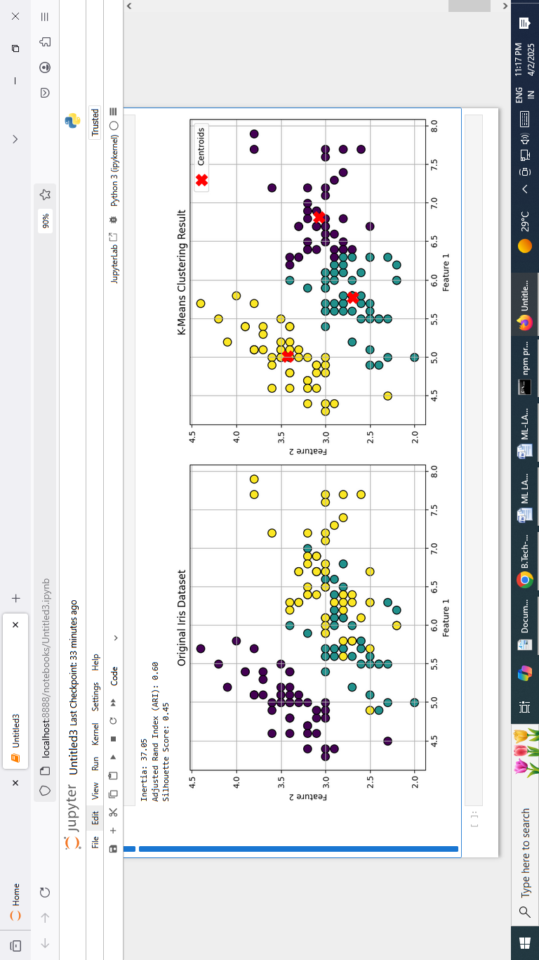

Week 9
9 | Performance analysis of Classification Algorithms on a specific dataset (Mini Project).
# Import required libraries
import numpy as np
import pandas as pd
from sklearn.datasets import load_iris
from sklearn.model_selection import cross_val_score
from sklearn.tree import DecisionTreeClassifier
from sklearn.neighbors import KNeighborsClassifier
from sklearn.linear_model import LogisticRegression
from sklearn.metrics import classification_report, confusion_matrix
import matplotlib.pyplot as plt
import seaborn as sns
# Load the Iris dataset
data = load_iris()
X = data.data
y = data.target
# Dictionary to store accuracy results for final comparison
accuracy_results = {}

1. Decision Tree Classifier

decision_tree = DecisionTreeClassifier()
dt_scores = cross_val_score(decision_tree, X, y, cv=5)
dt_accuracy = dt_scores.mean()
accuracy_results["Decision Tree"] = dt_accuracy
decision_tree.fit(X, y)
dt_y_pred = decision_tree.predict(X)
print("\nDecision Tree Results:")
print(f"Cross-Validation Accuracy: {dt_accuracy:.2f}")
print("Classification Report:\n",
classification_report(y, dt_y_pred, target_names=data.target_names))
dt_conf_matrix = confusion_matrix(y, dt_y_pred)
plt.figure(figsize=(6, 4))
sns.heatmap(dt_conf_matrix, annot=True, fmt="d", cmap="Blues",
xticklabels=data.target_names, yticklabels=data.target_names)
plt.title("Decision Tree - Confusion Matrix")
plt.xlabel("Predicted")
plt.ylabel("Actual")
plt.show()

2. K-Nearest Neighbors Classifier

knn = KNeighborsClassifier(n_neighbors=3)
knn_scores = cross_val_score(knn, X, y, cv=5)
knn_accuracy = knn_scores.mean()
accuracy_results["K-Nearest Neighbors"] = knn_accuracy
knn.fit(X, y)
knn_y_pred = knn.predict(X)
print("\nK-Nearest Neighbors Results:")
print(f"Cross-Validation Accuracy: {knn_accuracy:.2f}")
print("Classification Report:\n",
classification_report(y, knn_y_pred, target_names=data.target_names))
knn_conf_matrix = confusion_matrix(y, knn_y_pred)
plt.figure(figsize=(6, 4))
sns.heatmap(knn_conf_matrix, annot=True, fmt="d", cmap="Blues",
xticklabels=data.target_names, yticklabels=data.target_names)
plt.title("K-Nearest Neighbors - Confusion Matrix")
plt.xlabel("Predicted")
plt.ylabel("Actual")
plt.show()

3.Logistic Regression Classifier

logistic_regression = LogisticRegression(max_iter=200)
lr_scores = cross_val_score(logistic_regression, X, y, cv=5)
lr_accuracy = lr_scores.mean()
accuracy_results["Logistic Regression"] = lr_accuracy
logistic_regression.fit(X, y)
lr_y_pred = logistic_regression.predict(X)
print("\nLogistic Regression Results:")
print(f"Cross-Validation Accuracy: {lr_accuracy:.2f}")
print("Classification Report:\n",
classification_report(y, lr_y_pred, target_names=data.target_names))
lr_conf_matrix = confusion_matrix(y, lr_y_pred)
plt.figure(figsize=(6, 4))
sns.heatmap(lr_conf_matrix, annot=True, fmt="d", cmap="Blues",
xticklabels=data.target_names, yticklabels=data.target_names)
plt.title("Logistic Regression - Confusion Matrix")
plt.xlabel("Predicted")
plt.ylabel("Actual")
plt.show()

OUTPUT:

